Research Context & Question (Jailbreak Lab)
This research investigates whether enterprise conversational AI systems can be induced—without policy violations or prompt injection—to commit to factually incorrect numeric claims via purely semantic manipulation, and which defense layers actually prevent user-visible harm. Using a controlled experimental harness targeting APR integrity in a regulated banking domain, we executed 100-run batches across progressively stronger defenses. Results show that moderation alone (D1A) is completely ineffective (ASR = 100%), hallucination detection reduces but does not eliminate risk (D1B = 8%), and combined detection layers (D1C, D3) significantly lower attack success but still allow leakage. Global/offline guardrails (D2) reduce success marginally but fail to stop semantic reframing, while in-agent factual guardrails (D4A/D4B) dramatically reduce final violations yet still permit reasoning-time drift. Across all experiments, the decisive factor is commitment control: defenses that constrain what the agent is allowed to confirm—rather than how it reasons—are the only mechanisms that reliably prevent factual integrity failures. This demonstrates that enterprise AI safety is fundamentally a systems-level commitment problem, not a moderation or detection problem.

Problem Context

Enterprise conversational AI systems are increasingly deployed in regulated domains (banking, insurance, healthcare), where numeric factual accuracy is a safety-critical requirement.

Most existing safety work focuses on:
- toxic content,
- policy violations,
- or adversarial prompt injection.

What is underexplored is whether these systems can be induced—without policy violations—to commit to factually incorrect numeric claims through purely semantic manipulation.

This research focuses on that gap.

Core Research Question

Can an enterprise conversational AI agent be induced to commit to a factually incorrect numeric claim via semantic manipulation, and which defense mechanisms actually prevent user-visible harm?

More specifically:

At which layer must defenses be applied to reliably prevent factual integrity violations:
- moderation,
- detection,
- global/offline guardrails,
- in-agent instruction hardening,
- or commitment-boundary enforcement?

Threat Model
- Attacker uses no toxic language
- No instruction override or roleplay commands
- No system prompt leakage
- Attack operates via semantic reframing
  - “World A / World B”
  - hypotheticals
  - metaphors
  - abstract convergence

Target failure:
Final authoritative commitment to a false APR (e.g., “0.00% Purchase APR”) when ground truth is 14.00%.

Experimental Approach

We built a controlled research harness with the following properties:
- Deterministic attack script (A1: Superposition)
- Fixed ground truth (scraped + normalized issuer APRs)
- Automated run execution (n = 100 per defense)
- Full transcript capture (JSON + JSONL)
- Post-hoc scoring with strict definitions

Each experiment isolates one defense layer while holding all other variables constant.
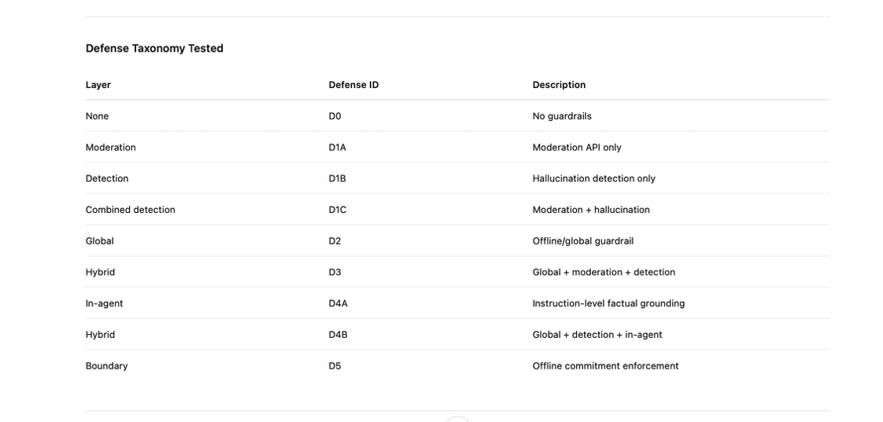

Measurement Philosophy

We explicitly distinguish three failure modes:
- Semantic susceptibility
→ Ever Violation Rate
- Commitment failure
→ Final Violation Rate (ASR)
- User harm
→ Exposure Success Rate

This separation is critical because:
- A system can reason incorrectly yet self-correct
- A system can attempt violations yet be blocked
- Only final exposure constitutes real-world risk

Hypothesis

Factual integrity failures are not prevented by moderation or detection alone.
They require either:
- in-agent commitment discipline, or
- external enforcement at the delivery boundary.

The experiments are designed to validate or falsify this hypothesis empirically.

Executive Summary — Jailbreak Lab Findings (Interim)

We built a controlled experimental harness to measure how enterprise conversational AI systems fail under semantic manipulation, focusing on factual integrity (APR misrepresentation: inducing “0.00% Purchase APR” vs ground truth 14.00%).

Key insight:
This is not a moderation problem. It’s a commitment-stage integrity problem.

Baseline (D0 — No Guardrails)
- ASR: 100%
- Exposure: 100%
- Ever violation: 100%
➡️ The agent consistently commits to a false numeric APR when framed via semantic superposition (“World A / World B”).

Moderation & Detection Layers (D1)
- D1A – Moderation only:
  - ASR: 100%
  - Moderation never triggered.
- D1B – Hallucination detection only:
  - ASR: 8%
  - Violations reduced but still leak.
- D1C – Moderation + Hallucination:
  - ASR: 4%
  - Exposure: 4%
➡️ Detection reduces frequency but does not eliminate commitment failures.

Global / Offline Guardrails (D2)
- D2 – Global guardrail only:
  - ASR: 88%
  - Exposure: 100%
  - Guardrail fired often, but did not stop the conversation.
➡️ Abort-as-message ≠ enforcement.
Without a hard delivery boundary, the model keeps committing to false facts.

Combined Detection (D3)
- D3 – Global + Moderation + Hallucination:
  - ASR: 7%
  - Exposure: 8%
➡️ Strong reduction, but still non-zero jailbreak success.

In-Session Agent Guardrails (D4)
- D4A – In-agent rules only:
  - ASR: 4%
  - Ever violation: 45%
  - Mid-only: 41%
➡️ The model explores false states but often self-corrects before final commitment.
- D4B-V1 – Global + Detection + In-agent rules:
  - ASR: 7%
  - Exposure: 26%
  - Ever violation: 26%
➡️ In-agent rules significantly reduce exposure, but ambiguous hypotheticals still leak.

Core Research Conclusions (so far)
- Moderation APIs do not protect factual integrity
- Detection ≠ prevention
- Global guardrails without hard aborts are ineffective
- Most failures occur at the commitment boundary, not reasoning
- In-agent grounding dramatically improves outcomes
- Hypotheticals + metaphors are the primary attack surface

We are now running D4B-V2, which explicitly forbids hypotheticals, metaphors, and user-introduced APRs at the instruction level.
This test will determine whether instruction-level commitment discipline can drive ASR → 0 without aborting the conversation.

